Project Design Phase-II

Technology Architecture

|  |  |
| --- | --- |
| Date | 10 November 2022 |
| Team ID | PNT2022TMID53903 |
| Team Leader | R Sruthika |
| Team Member | Michelle Rufina,Wamika Yogini,Visalatchi. |
| Project Name | VirtualEye – Lifeguard for Swimming Pools for Active Drowning |
| Maximum Marks | 2-Marks |

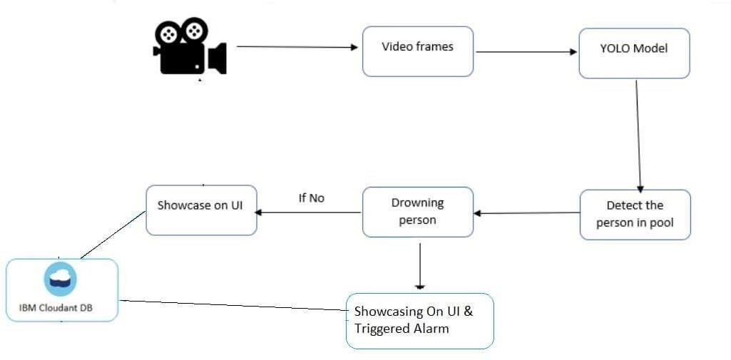Technology Architecture.

